Project Performance Testing

Date | 8 July 2026
Team ID | SWTID-2026-5839
Project Name | Visualizing Housing Market Trends: An Analysis of Sale Prices and Features using Tableau
Maximum Marks

Model Performance Testing:
S.No. | Parameter | Screenshot / Values
1. | Data Rendered | The housing dataset was successfully uploaded and rendered in Tableau Public. All dataset fields, including Sale Price, Bedrooms, Bathrooms, Flat Area, Floors, Basement Area, House Age, Renovation Status, Overall Grade, were loaded correctly and made available for further analysis.  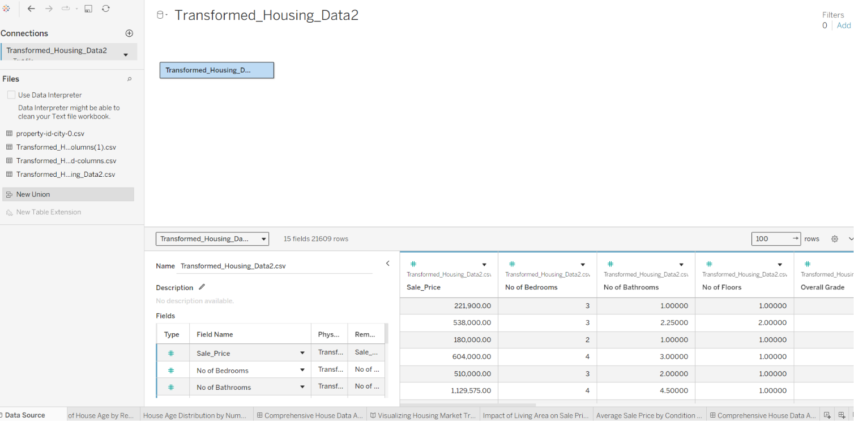
2. | Data Preprocessing | Removed null values, verified data types, created calculated fields, grouped Zipcode (1–9), validated renovation and condition fields before visualization.  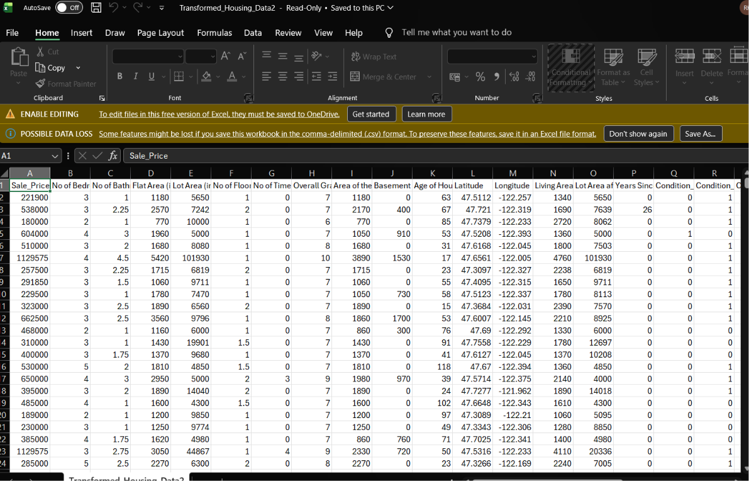
3. | Utilization of Filters | Filters used: Sales Price, Years Since Renovation, Number of  Bedrooms, Number of Bathrooms, Number of Floors, House Condition, Ever Renovated Yes, Since Renovation Year and Waterfront View.  Filters used across different worksheets: Year of Dates (2019 vs 2020), Month of Dates (January to December), Regions (ER, NER, NR, SR, WR), Top N, and Bottom N parameters.  Aggregation functions: SUM(Usage) was primarily used for total load mappings, and AVG(Usage) was applied to monitor ongoing baseline shifts. Worksheets utilize coordinated dynamic action filters to allow synchronized dashboard cross-filtering.
4. | Calculation fields Used | IN this Visualization (Total Sales by Years Since Renovation) Use Create Calculation field and other visualization normal calculation fields Use.  Logic / Syntax: Mapped via custom integer parameters linked with rank/index functions (INDEX()) to dynamically filter states based on the selection.  Purpose: Solves Tableau's order of operations conflict, allowing the dashboard to dynamically rank the top or bottom states within specific geographical region filters without breaking.
5. | Dashboard design | - Count of Transformed Housing Data.  - Average Sale Prices  - Area of House from Basement (Sqft)  - Total Sales by Years Since Renovation  - Distribution of House Age by Renovation Status  - House Age Distribution by Bathrooms, Bedrooms and Floors.  - Impact of Living Area on Sale Price  - Average Sale Price by Condition and View  All Visualization in use Dashboard Design (Comprehensive House Price Analysis,Comprehensive House Price) 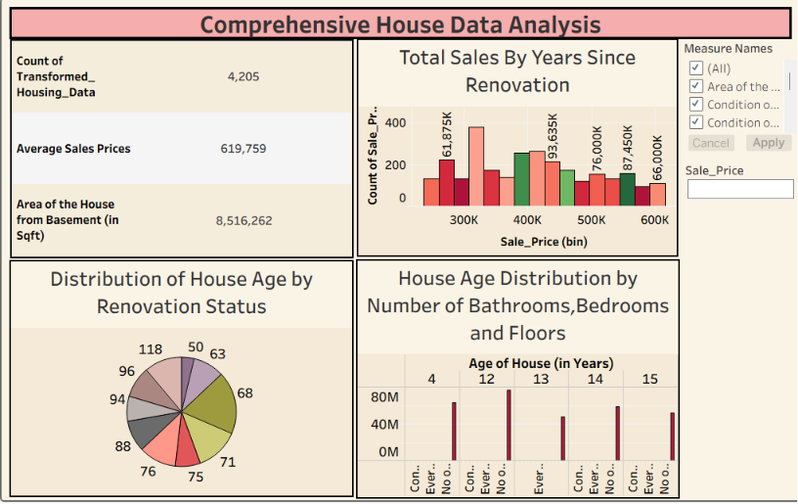  f.g.->Deshbord 1  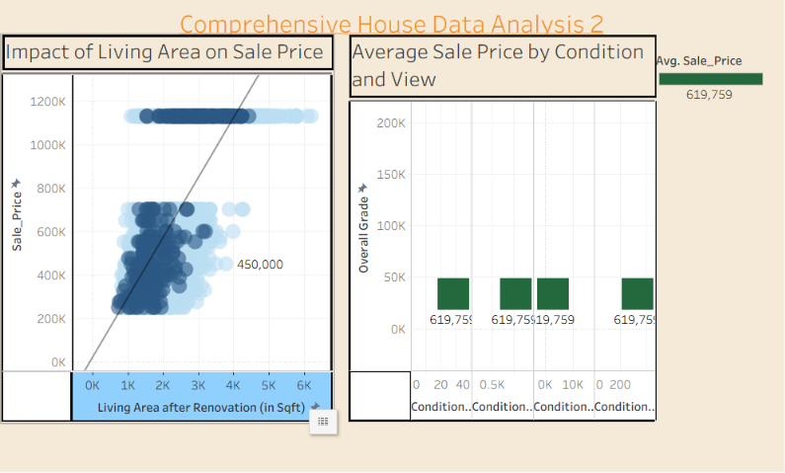  f.g->Deshbord 2
6. | Story Design | Visualizing Housing Market Trends: An Analysis of Sale Prices and Features using Tableau Story .Multipal stories are created into the Tabula story .

